**4COSCO11C.2 Web Design and Development**

**Tutorial 3**

### Task 1 - Create your Web Page content

Create a file and save it as **tutorial3.html**

Your Web Page should follow the following specifications.

#### **Part 1**

Your Web Pages should follow the following specifications.

* Tutorial 3 for the title.
* 'My Useful Links' as the page heading.
* Add a background colour or a background image to the body of your page using an embedded style sheet.
* Your page should be composed of at least 3 parts, one of which will be your tutorial work so far. For each part you will have:
  + A subheading
  + A list of useful links with a quick description of each site. You will use a [description list](https://intranet.ecs.westminster.ac.uk/modules/4COSC011W/lists.html#description) for this.
* The page should contain a series of links at the top which will act as anchors to each of the categories on your page. (Note: you will need some length to your page for the anchors to work).
  + Use a HTML unordered list to structure the links and use CSS to style the list horizontally.
* Add a back to top link (hint: you want to link back to your starting <h1> tag)
* Add a small image to act as a back to top icon.



You can look for some on the web (e.g. <https://www.iconfinder.com/>).

**Important Note:** You must ensure you comply with the image license agreement.

* A ruler acting as a separator
* Your email address inside an address element
* The last modified date (just as hard coded date)
* Use CSS link pseudo-classes to style the links differently depending on which of the four states they are in.
* Remember, you can check if your markup is syntactically valid using the Validator at: <https://validator.w3.org/>  
  + Use the ‘Validate by File Upload’ or ‘Validate by Direct Input’.

See Below for an example of your page layout:

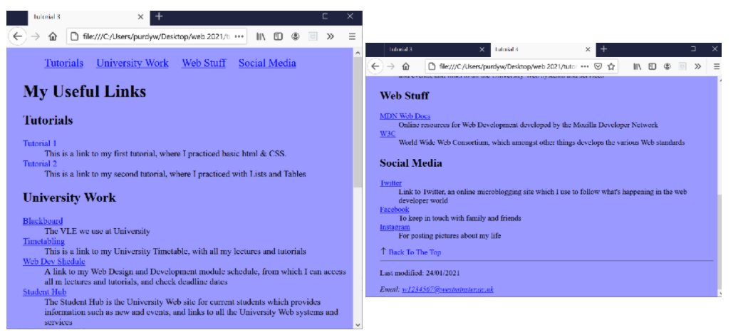

#### **Part 2 - Create a Fixed Horizontal Navigation Bar**

* Use fixed positioning so that the list of anchor links at the top of your page is a horizontal navigation bar that always appears at the top of the web page when you page down. (Note: you will need some length to your page for this to work).
  + To achieve this create two <div> sections in the body of your document.
    - The first section will contain the navigation bar.
    - The second section will contain the heading, subheadings, and links with descriptions.

See Below for an example of the fixed Navigation Bar. Image 2 shows the fixed Navigation Bar when scrolling down the page.

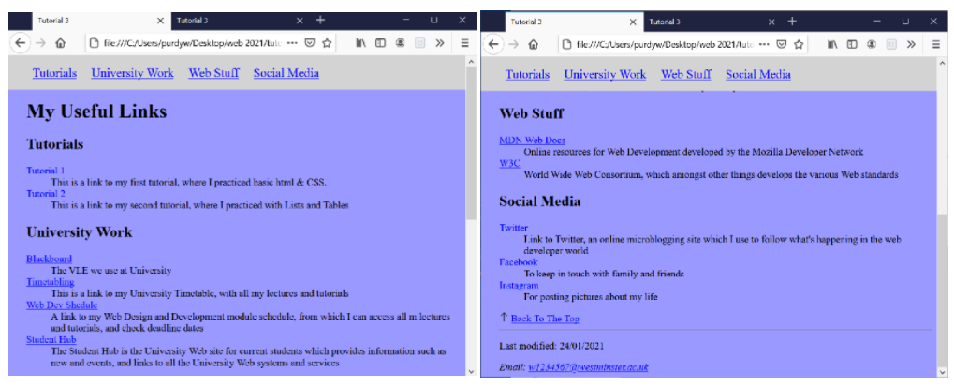

Task 2 - Complete the Tutorial 3 Test on Blackboard

* Go to Assessment -> Tutorial Tests -> Tutorial 3 Test and complete the test. You can have up to five attempts to get the maximum score of 2 marks